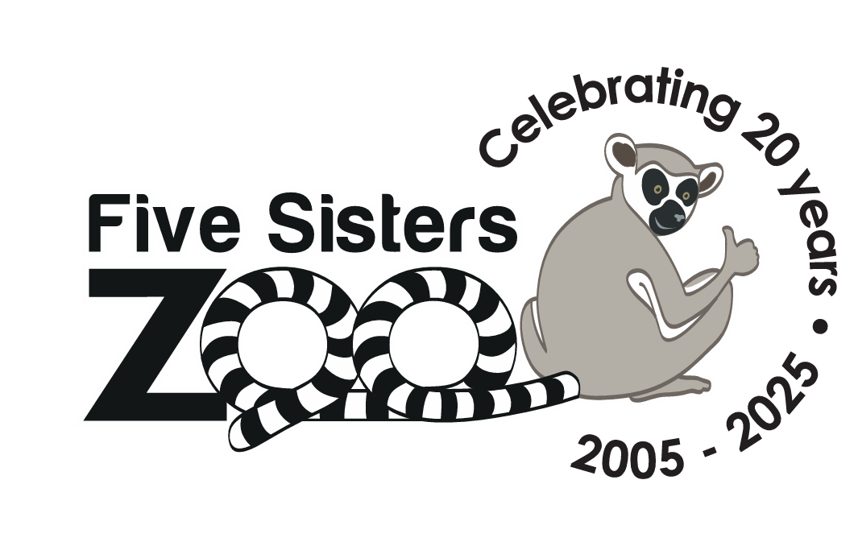
Volunteer Application 2026
Thank you for your interest in volunteering with Five Sisters Zoo! Please fill out the application below and return it to education@fivesisterszoo.co.uk no later than 5pm on the 21st of January 2026.
Once your application has been submitted, it will be reviewed you’ll be contacted regarding next steps in the process. Please don’t worry if you don’t receive an immediate response as we will be reviewing all applications after the closing date.
Name:
Address:
Volunteer Role Interested In (select only 1):
Animal Care Visitor Engagement
Why Do You Want to Volunteer at Five Sisters Zoo? (Please limit this response to 250 words or less)

Your Work and Volunteer History: Please copy and paste your CV or an equivalent document here. Alternatively, you may attach it to your response email when you send this form back.

